 **Sales Analysis Dashboard – Excel Power Pivot & DAX**

**-by Marwa Riyaz**

**Project Overview:**

I built an **interactive sales dashboard** using **Excel Power Pivot and DAX** to analyze over **1,000 customer orders**. The goal was to turn raw data into actionable business insights for revenue growth, customer behavior, and operational performance.

The project covers **data modeling, KPI creation, and executive dashboard design** – showing how I approach data analysis end-to-end.

**Key Objectives**

* Track overall **sales performance** (revenue, orders, customer spend).
* Understand **seasonal trends and category performance**.
* Measure **average delivery time** across orders.
* Identify **top products and cities** driving sales.
* Build an **executive-ready dashboard** for decision making.

**🛠 Tools & Methods:**

* **Excel Power Pivot** → data modeling across multiple tables (Orders, Customers, Products).
* **DAX Measures** created for:
  + Total Revenue
  + Total Orders
  + Average Customer Spend
  + Average Delivery Time
* **Pivot Charts & Slicers** for interactive filtering (Date, Occasion, City, Category).
* Dashboard design focused on clarity and professional reporting.

** Metrics & KPIs:**

* **Total Orders:** 1,000
* **Total Revenue:** $3.52M
* **Avg. Customer Spend:** $3,520.98
* **Avg. Delivery Time:** 5.53 days

** Insights I Found:**

**🔹 Sales Drivers**

* **Occasions:** Valentine’s Day, Raksha Bandhan, and Holi had the highest revenue.
* **Categories:** Cakes and Soft Toys were the strongest revenue contributors.
* **Products:** Gift sets and combos were consistently popular across occasions.

**🔹 Customer Trends**

* Spending peaks during **festive months** (Feb, Aug, Sep).
* Orders spike during **morning (9–11 AM)** and **evening (6–9 PM)**.

**🔹 Geography**

* Top cities included **Imphal, Kovil, North Dumdum**.
* Tier-2 cities show strong growth opportunities.

** Recommendations:**

* Double down on **festive occasion campaigns**.
* Expand **Cakes & Soft Toys** inventory and promotions.
* Launch **time-based offers** during morning/evening peak hours.
* Focus marketing budgets on **top 10 performing cities** while exploring growth markets.

**📊 Dashboard Preview**

*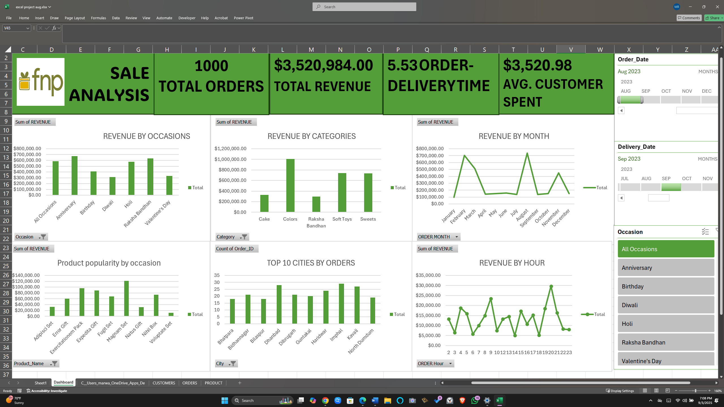 (– I’ve included visuals in the repository)*

** What I Showcased in This Project:**

* Data modeling with **Power Pivot**
* Writing **DAX Measures** for KPIs
* Designing an **interactive executive dashboard**
* Translating data into **business insights & strategy**
* Presenting analysis in a **professional, decision-maker friendly format**

**🔗 Portfolio Use:**

I’m sharing this project as part of my **data analytics portfolio**.

* 📂 Full files & dashboard on **GitHub: https://github.com/MarwaRiyaz/FNP-Sales-Analysis-Dashboard-**
* 📌 **LinkedIn: www.linkedin.com/in/marwa-riyaz-896046258**

✨ This project reflects how I approach analytics: **clean data → strong KPIs → clear storytelling → actionable recommendations.**